Software Requirements Specification

Version 1.0 May,21,2020

FLATS RENTING MANAGEMENT SYSTEM

Soulaf Ayoush Yara Mayoos

Submitted in homework Of the requirements of CS 310 Software Engineering

Table of Contents

Table of Contents ..................................................................................................................................

1.0. Introduction 1

1.1. Purpose 1

1.2. Scope of Project 1

1.3. Glossary 1

1.4. References 2

1.5. Overview of Document 2

2.0. Overall Description ............................................................................................................ 3 2.1

2.1System Environment ....................................................................................................................... 3

2.2 Functional Requirements Specification .......................................................................................... 3 2.2.1 admin Use Case.................................................................... Error! Bookmark not defined.

2.2.2 Customer Use Case ..................................................................................................................... 4

2.2.3 Update customer :Use Case ................................................................ Error! Bookmark not defined.

2.3 User Characteristics ........................................................................................................................ 6 2.4 Non-Functional Requirements ........................................................................................................ 6

3.0 Requirements Specification .......................................................................................... 8

3.1 External Interface Requirements .................................................................................................... 8

3.2 Functional Requirements ................................................................................................................ 8 3.2.1 Search flat ......................................................................................................................... 8

3.2.2 renting......................................................................... Error! Bookmark not defined.

3.2.3 Update Flat Availability ........................................................ Error! Bookmark not defined.

3.2.4 payment ........................................................................ Error! Bookmark not defined.

3.2. 5 Generating Receipt ................................................................. Error! Bookmark not defined.

3.3 Detailed Non-Functional Requirements ........................................ Error! Bookmark not defined.

3.3.1 Logical Structure of the Data ................................................. Error! Bookmark not defined.

# 1.0. Introduction

## 1.1. Purpose

This document provides a definition of the website system for renting flats at the beach in summer

## 1.2. Scope of Project

This system will provide 3 scopes:

1. for the customer to add his renting
2. the admin for website to manage renting
3. the admin for flats to confirm the renting

## 1.3. Glossary

|  |  |
| --- | --- |
| Term | Definition |
| Flats | This is the product that the flats will give to the customer And also event |
| admin | Who is the manager for website to manage flats |
| Database | Collection of all the information monitored by this system. |
| Flats admin | This the person that he add flats and events and manage products from his control panel |
| Field | A cell within a form. |
| Reader | Anyone visiting the site to read articles. |
| Review | A written ratings about the appropriateness of a flat ; may include suggestions for improvement. |
| customer | A person that he rented the product flat . |
| Software Requirements Specification | A document that completely describes all of the functions of a proposed system and the constraints under which it must operate. For example, this document. |
| Stakeholder | Any person with an interest in the project who is not a developer. |
| User | flats admin or customer or admin |

## 1.4. References

IEEE. IEEE Std 830-1998 IEEE Recommended Practice for Software Requirements Specifications. IEEE

Computer Society, 1998.

## 1.5. Overview of Document

The next chapter, the Overall Description section, of this document gives an overview of the functionality

of the product. It describes the informal requirements and is used to establish a context for the technical requirements specification in the next chapter.

The third chapter, Requirements Specification section, of this document is written primarily for the

developers and describes in technical terms the details of the functionality of the product.

Both sections of the document describe the same software product in its entirety, but are intended for

different audiences and thus use different language

.

2.0. Overall Description

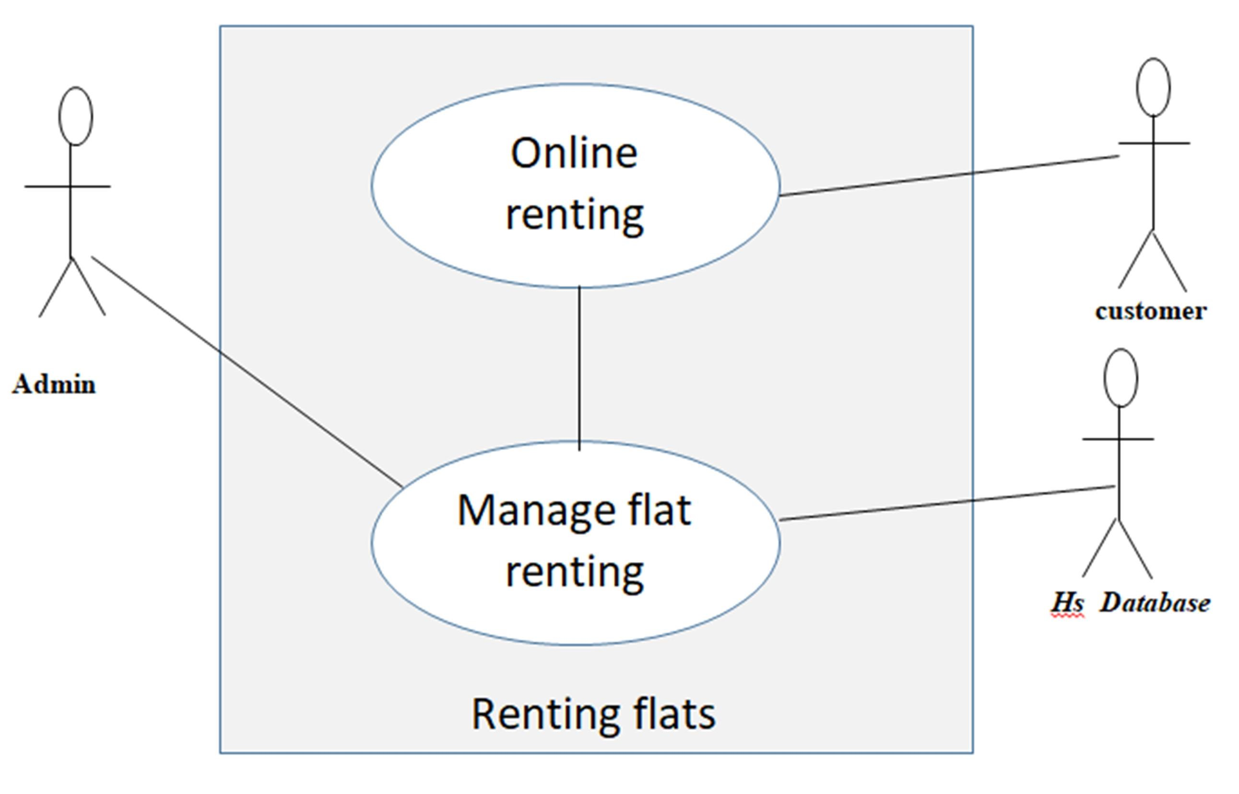

2.1 System Environment

The renting system has three active actors and one cooperating system. The customer, admin, or flats admin accesses the online renting through the Internet. Any admin communication with the system is through control panel. The customer accesses the entire system directly.

2.2 Functional Requirements Specification

This section outlines the use cases for each of the active readers separately. The reader, the author and the reviewer have only one use case apiece while the editor is main actor in this system.

2.2.1 admin Use Case

In case of multiple admin, this term refers to the principal admin, with whom all communication is made.

Use case: admin use case Diagram:

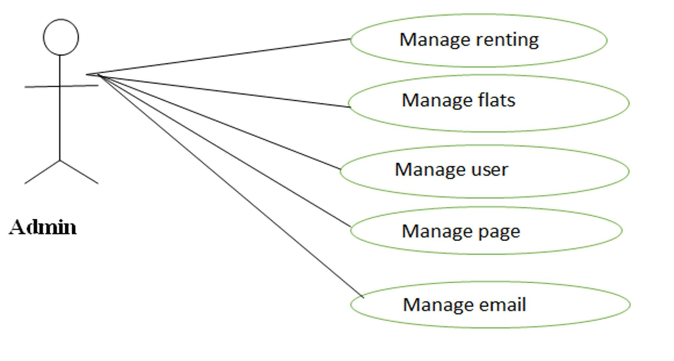

Brief Description

The admin confirms the renting.

Initial Step-By-Step Description

Before this use case can be init. iated, the admin has already connected to the Online Renting System.

1. The admin chooses the reservation to confirm it.
2. The admin click on confirm the email will send to customer that your flat confirmed
3. The System generates and sends an email acknowledgement.

Xref: Section 3.2.2, admin

2.2.2 Customer : Use case Diagram:

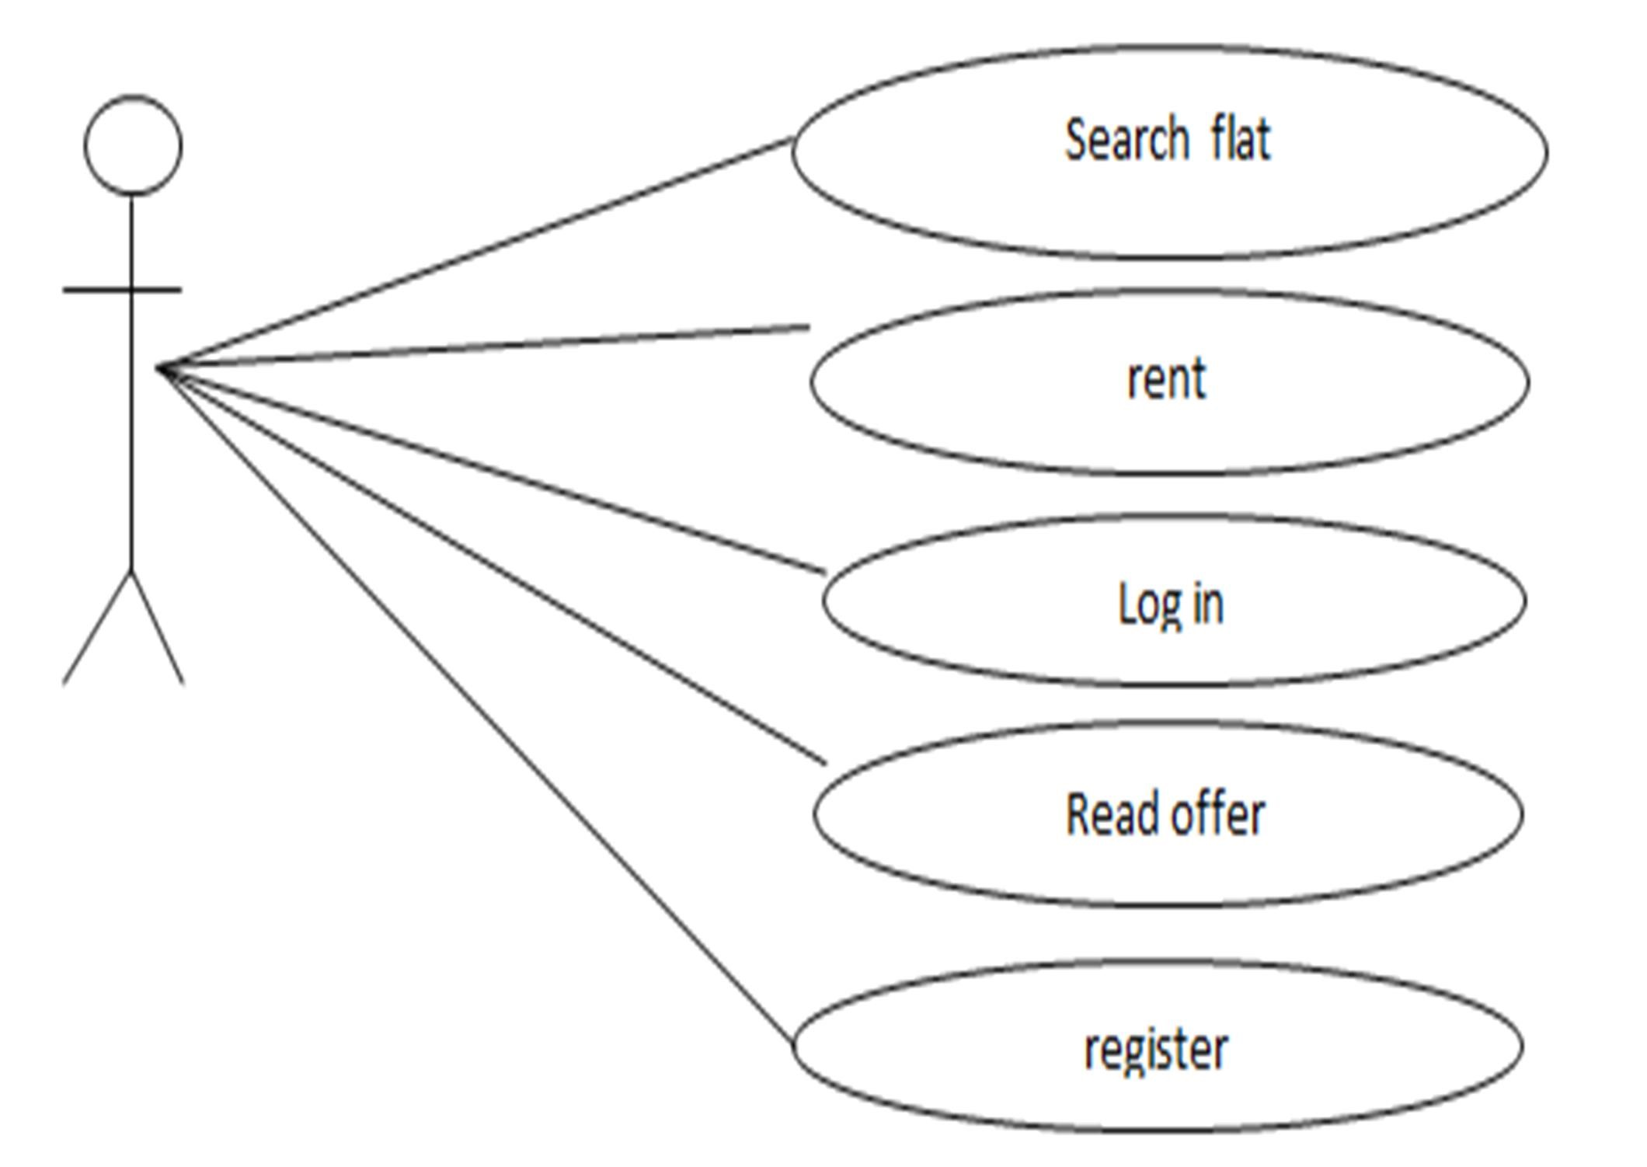

Brief Description

The customer accesses the Online Renting Website, searches for an flat and reserve it.

Initial Step-By-Step Description

Before this use case can be initiated, the customer has already accessed the Online renting system.

1. The customer chooses to search by price, location, or keyword.
2. The system displays the choices to the Customer.
3. The customer selects the flat or event desired.
4. The system presents the details of the order to the customer.

2.2.3 Update cutomer : Use case Diagram:

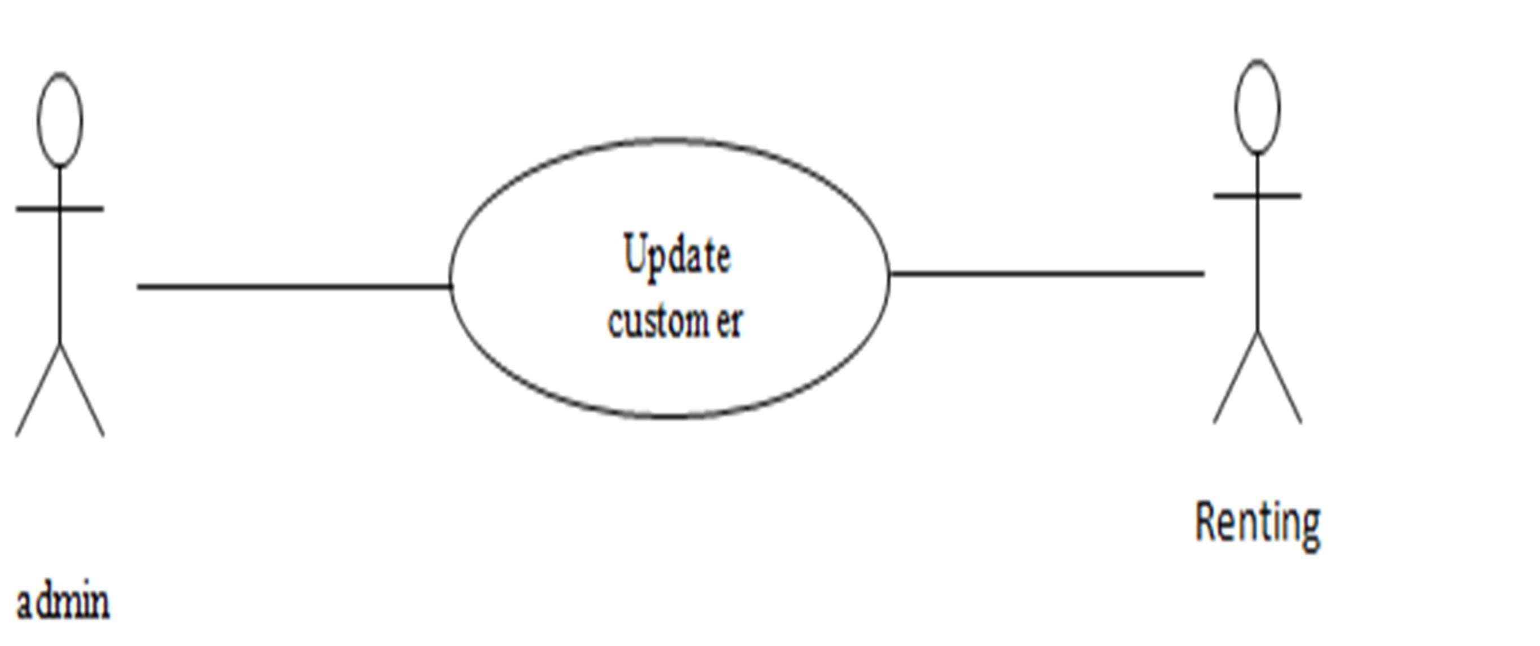

Brief Description

The admin enters a new customer or updates information about a current customer.

Initial Step-By-Step Description

Before this use case can be initiated, the admin has already accessed the main page of the web Manager.

* 1. The admin selects to Add/Update customer.
  2. The system presents a choice of adding or updating.
  3. The admin chooses to add or to update.
  4. The system links to the online renting Database.
  5. If the admin is updating a customer, the system and presents a grid with the information about the customer; else the system presents list of members for the admin to select a customer and presents a grid for the person selected.
  6. The admin fills in the information and submits the form.
  7. The system verifies the information and returns the admin to the Manager main page.

Xref: Section 3.2.4, Add customer; Section 3.2.5, Update Person

Brief Description

The admin flats enters information about an existing flat.

Initial Step-By-Step Description

Before this use case can be initiated, the admin flats has already accessed the main page of the Manager.

1. The admin flats selects to Update flats.
2. The system presents s list of active flats .
3. The system presents the information about the chosen flats.
4. The admin flats updates and submits the form.
5. The system verifies the information and returns the admin flats to the Manager main page.

Xref: Section 3.2.6, Update flats Status

* 1. User Characteristics

The customer is expected to be Internet literate and be able to use a search engine. The main screen of the

Renting online system will have the search function and a link to “flats details Information.”

The customer and admin flats are expected to be Internet literate and to be able to use chat.

The admin is expected to be Windows literate and to be able to use button, pull-down menus, and similar

tools.

The detailed look of these pages is discussed in section 3.2 below.

* 1. Non-Functional Requirements
     + - The system must ensure that all the transferable data as for examples customers credit or debit

card number, CVV Code, e-payment should be done in secured connection.

* + - * The system must be able to handle multiple transactions a time.
      * The system must provide customers 24*7 hours online renting service.
      * The system should support almost all the browsers (Internet Explorer, Safari, Chrome, and

Firefox).

* + - * The system should be able to convert the price from R.S to USD.
      * System should send the newsletter about ongoing promotions or deal to registered customers.
      * Customers need to cancel the renting before 24 hrs. Otherwise their credit card will be charged

for one day.

* + - * In promotion time the system will charge credit card promptly.

3.0. Requirements Specification

* 1. External Interface Requirements

The only link to an external system is the link to the flats Renting (HB) Database to verify the membership

of a customer. The admin believes that a admin flats has to confirm the renting. The HB Database fields of interest to the flats renting System are member’s name, membership (ID) number, and email address (an optional field for the HB Database).

* 1. Functional Requirements

* + - * The system supports customers renting and able to modify them
      * Customers can search based on flats, apartment,
      * When a customer search for flats, apartment, and the search result must contain flats or apartment

information (Address, Ratings, and Price) and also its availability within choosing check in and checkout date.

* + - * Customers able to cancel their renting from their account.
      * Staffs able to edit customers renting information (updating check in, check out, flat preferences,

bed preferences and also cancelling renting).

* + - * Customers can book online and pay with credit or debit card.
      * The system must send renting confirmation email after successful payment.
      * Customers can write reviews about flats and apartment and also rate them.
      * Customers able to check their renting status from their individual account.
      * Customers can send feedback or call the company for renting purposes.

* + 1. Search flat

|  |  |
| --- | --- |
| Use Case Name | Search flat |
| XRef | Section 2.2.1, Search flat |
| Trigger | The customer assesses the flats renting Website. |
| Precondition | The Web is displayed with grids for searching. |
| Basic Path | 1. The customer chooses how to search the Web site. The choices are by price, by Category, by location, and by Keyword. |
|  | 1. If the search is by Keyword , the system creates and presents an alphabetical list of all Keyword in the database. In the case of a flats with multiple flats, each is contained in the list. 2. The customer selects an flat. 3. The system creates and presents a list of all flat by that location in the database. 4. The customer selects an flat. 5. The system displays the details for the flat. 6. The customer selects to book the flat or to return to the flat list or to the previous list. |
| Alternative Paths | In step 2, if the customer selects to search by category, the system creates and presents a list of all categories in the database.   1. The customer selects a category. 2. The system creates and presents a list of all flats in that category in the database. Return to step 5.   In step 2, if the customer selects to search by keyword, the system presents a dialog box to enter the keyword or phrase.   1. The customer enters a keyword. 2. The system searches the details of flats with that keyword and creates and presents a list of all such flats in the database. Return to step 5. |
| Postcondition | The selected flat is reserved. |
| Exception Paths | The customer may abandon the search at any time. |
| Other | The categories list is generated admin . |

* + 1. Renting :

|  |  |
| --- | --- |
| Name : | Renting |
| Actor : | Customer |
| Description : | Describe the process used to add a new renting |
| Successful Completion : | 1. Customers can book 2. Staffs enter the customers details into the database |
| Alternative : | None |
| Precondition : | Customers registered as a member |
| Post condition : | Flat is booked by customer |
| Assumption : | None |

* + 1. Update Flat Availability

|  |  |
| --- | --- |
| Name : | Update Flat Availability |
| Actor : | Staff |
| Description : | Can update the availability of flats’s flat |
| Successful Completion : | 1. New availability for flats’s flat 2. Staffs enter the available flat details into the database |
| Alternative : | None |
| Precondition : | Staffs update the system entering new flat availability |
| Post condition : | Customers can see the latest availability of flats’s flat |
| Assumption : | None |

* + 1. Payment

|  |  |
| --- | --- |
| Name : | Payment |
| Actor : | Customer |
| Description : | Describe the process of payment through the system |
| Successful Completion : | 1. Customers will receive the invoice 2. Staffs enter the customers payment details into database |
| Alternative : | Pay after arrive into the destinations |
| Precondition : | Customers registered as a member |
| Post condition : | Flat is booked by customer |
| Assumption : | None |

* + 1. Generating Receipt

|  |  |
| --- | --- |
| Name : | Generating Receipt |
| Actor : | Staff |
| Description : | Describe the process used to generate the renting details |
| Successful Completion : | 1. Staff can check the renting details 2. Staffs will keep the copy of the generated receipt |
| Alternative : | None |
| Precondition : |  |
| Post condition : | Flat is booked by customer |
| Assumption : | None |

3.3 Detailed Non-Functional Requirements

3.3.1 Logical Structure of the Data

Admin flat

Admin

flat

customer

rents

confirm

deal with

has

The data descriptions of each of these data entities is as follows:

Customer Data Entity

|  |  |  |  |
| --- | --- | --- | --- |
| Data  Item | Type | Description | Comment |
| Name | Text | Name of principle Customer |  |
| Email  Address | Text | Internet address |  |
| Phone | Integer | Number of  Customer |  |
| FlatNum | Integer | Number of flat which has rented |  |

flat Data Entity

|  |  |  |  |
| --- | --- | --- | --- |
| Data Item | Type | Description | Comment |
| Name | Text | Name of principle author |  |
| ID | Integer | ID number of flat |  |
| Address | Text | Internet address |  |
| Price | Integer | Price of flat |  |
| Status_ | boolean | Flat is Empty or not |  |

Admin Data Entity

|  |  |  |  |
| --- | --- | --- | --- |
| Data Item | Type | Description | Comment |
| Name | Text | Article entity |  |
| ID | Integer | ID number of admin |  |
| Email | Text | Reviewer entity |  |
| Register | Text | Information of customer |  |

Admin Flat Data Entity

|  |  |  |  |
| --- | --- | --- | --- |
| Data Item | Type | Description | Comment |
| Name | Text | Article entity |  |
| ID | Integer | ID number of admin flat |  |
| Email | Text | Email Address |  |
| Manage_flat | Text | Manger of flat |  |